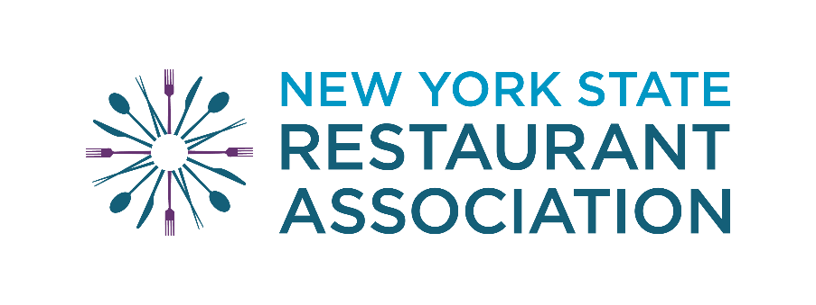

NYS Restaurant Association Rochester Chapter
2026 Scholarship Application
supporting future generations of chefs, restaurateurs, managers, and all culinary and hospitality professionals

Sponsored by:
NYSRA Rochester Chapter
2781 St. Paul St., Rochester, NY 14617
nysraroc@gmail.com www.nysra.org

Complete applications must be received or postmarked by:
June 30th, 2026
Incomplete or late applications will not be considered.

NYSRA Rochester Chapter
$5000 SCHOLARSHIP APPLICATION

Scholarship Eligibility and Selection Criteria:
- Applicant must be a resident of: Monroe, Ontario, Wayne, or Livingston County.

- Applicant must be accepted and committed to attending a college or university for the fall term, studying in the field of culinary or hospitality.

- Applicant must be a high school graduating senior, or returning college student.

- Applicant must submit either a video or 250 word essay focusing on their background and future plans in the relevant fields.

- Applicant must submit two letters of recommendation:
  - One from a school counselor or teacher
  - One from a member of the community: church leader, work supervisor, etc, who is not a family member or relative.
- Applicant must submit a completed application by June 30th.

Note: If selected, you will receive a scholarship from NYSRA Rochester Chapter Scholarship Fund in the amount of $5000, paid directly to the school in which you are enrolled.

Complete applications must be received or postmarked by:
June 30th, 2026
Incomplete or late applications will not be considered.

2026 NYSRA Rochester Chapter
SCHOLARSHIP APPLICATION

**Please complete ALL sections, if it doesn’t apply, please write “n/a”. Print legible or type in blue or black ink only. DO NOT USE A PENCIL.
Name:
Address:
Student’s Cell number:
Student’s Personal Email
(not from School):
Parent’s Cell number:
Parent’s Email:
All communications between NYSRA and the applicant will be sent to the emails provided, please make sure to check your email for updates and confirmations.
High School:
Counselor’s Name:
Phone / Email:

Field of study when attending college:
What college are you attending in the Fall of 2026?
College Financial Aid Office Address:
If you made your FINAL decision on college, please include a copy of the college acceptance letter with this application.

If you haven’t made a final decision on a college or have been waitlisted,  please list your options here. Once off the waitlist, you must notify NYSRA by 07/31 | Have you been accepted?
 | Yes | No | Pending

Do you work? | Yes |  | No
If yes, where?
Name of supervisor:
Phone / Email:
**If chosen, applicant will be contacted to confirm college enrollment so scholarship can be mailed directly to the school and applied to applicant’s account.

- Awards, honors, and achievements
Please list any academic achievements, sports awards, or community recognitions you have received while in high school.
Award: | Date:

Extracurricular activities
Please list any extracurricular activities or personal interests (clubs, sports, etc.) while in high school.

Activity: | Date:

III. Community service/volunteer work, and practical work skills in the relevant fields. Please list any initiatives, volunteering, or participation in community events while in high school, as well as any skills developed while working a paid job in culinary or hospitality.
Activity: | Date:

- Letters of Recommendation Request TWO letters of recommendation and list their names, their relationship to you, and their email addresses. Copies of generic letters of recommendation sent to the college will NOT be accepted.
Name / Occupation: | Relationship to you: | Email Address
These letters should be sent to:
NYSRA Rochester Chapter
2781 St. Paul Blvd.
Rochester, NY 14617
Letters of recommendation must be received or postmarked by JUNE 30th. You can also include the letters of recommendation with your application packet.

Please include a short essay (at least 250 words) or a short video describing:
  - Your background
  - Career Goals – please be specific on your choice of study (for example: culinary, hospitality management, etc)
  - Why do you deserve a scholarship?
Note: The essay must be written by the applicant. Essays written by school counselors or AI will NOT be accepted. Videos should be emailed to nysraroc@gmail.com.

Note: This scholarship is not transferable if the student changes their field of study or college.
This scholarships is provided to students because of their specific career choice. If the student decides to study something else or attend another college after their scholarship designation, he/she forfeits the award. The decision will be made by August 1st, and paid directly to the school in which you are enrolled.

Statement:
I personally read and understand all the details of this scholarship application, and ALL OF THE ABOVE STATEMENTS ARE TRUE TO THE BEST OF MY KNOWLEDGE.

Applicant’s Signature:
Date:

If you have any questions, please contact us at by email at: nysraroc@gmail

NYS Restaurant Association
SCHOLARSHIP APPLICATION
Student’s Checklist

Have you included ALL the following information?

A completed application (ALL sections MUST be completed)
Two letters of recommendation. No form/template letters, please!
Essay or Video
Acceptance letter from college/university, or other proof of attendance.

Important Note: If you requested your high school counselor or another individual to send us letters of recommendation on your behalf by regular mail or email, please make sure to follow up with them to ensure ALL documents are received or postmarked June 30th.

Return the application and required paperwork to: NYS Restaurant Association, Rochester Chapter 2781 St. Paul Blvd.
Rochester, NY 14617

or by email to: nysraroc@gmail

Applications must be received or postmarked by June 30th.
Incomplete or late applications will NOT be considered.

